Buggu Game Screenshot Gallery

This is a screenshot gallery going through all the features of Buggu Game. Here there will be pictures showing off each of the assignment requirements, for those who would like more information than the provided video.

1./2.

When you first open the page, you’re greeted to the game’s instructions. You can choose your difficulty, and after clicking “Play” and allowing it to load, you’re met by a circular dish (what we call the petri dish). It’s centered on the origin, (0,0) in our GL Canvas and viewed from above.

3.

The bacteria start at random, arbitrary spots on the edge of the petri dish, and grow uniformly as time goes on. We added walls to the petri dish, so you can’t see growth outside of the dish, but it’s evident that they grow the same on all sides.

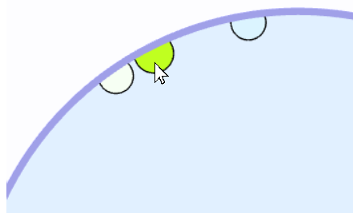4./5.

The goal of the game is to defeat every bacterium, and so when you click on a bacterium, (or anywhere for that matter), you spawn a drop of poison – but more on that later. That poison immediately kills the bacteria, removing it from the game, bringing you one step closer to victory. It isn’t immediate, but that’s because we have a cool explosion effect that takes place as the bacteria dies – again, more on that later.

6.

This is inside the “Bug”’s constructor. The “switch” statement is used to assure that we have bright, noticeable colors, rather than muddy, dark ones.

Initially, the game generates 10 different bacteria all with different, randomly generated colors! Here’s a snippet of the code that lets that happen (see video for full code breakdown).

7.

When inquired about what a “crust” is, the professor said that it just means that the bacteria are circles on the edge of the disc. So that’s what we did. We see how the growth inward can make the bacteria look like a “crust” of sorts.

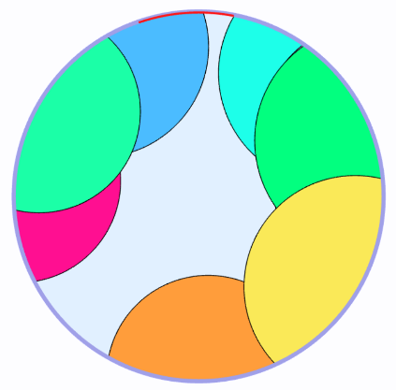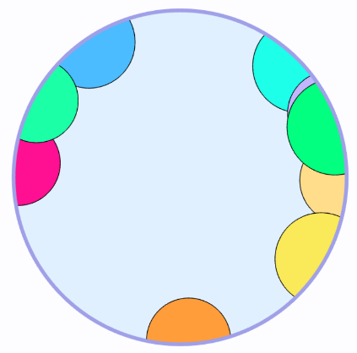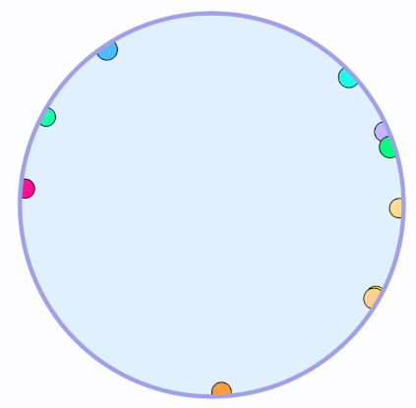8. For a bit of variety, we took the losing condition to be a 30 degree arc on the edge of the petri dish. If two bacteria manage to make it into the petri dish before you are able to kill them, then you lose. As a signal that you’ve lost, the game stops and the goal is drawn. There is an internal counter that keeps track of if a cell has reached the goal.

The game stops when 2 bacteria reach the goal, as the Blue and Cyan have. The goal is then shown.

Start of the game

The moment that the first bacteria breaches the goal. Note: we aren’t informed of this occurrence, only the game knows

The randomness of the cell’s position and growth rates makes for some very interesting losing conditions. Here are 3 examples, and why the user lost:

This one is the most common case. Yellow got into the goal and Mint reached from the other side.

In this one, the bacteria spawned pretty close to the goal. The cream bacteria was the first to get in, then the purple, bringing a loss from the same side

This is an edge case, if for whatever reason, the user was really slow, this can happen. You can see that Olive had completely encased the goal, but that’s just one. It isn’t until Pink reached the goal that the player actually loses.

You can see that with this version of the lose condition, you can have a variety of different types of games, even on the different difficulty settings.

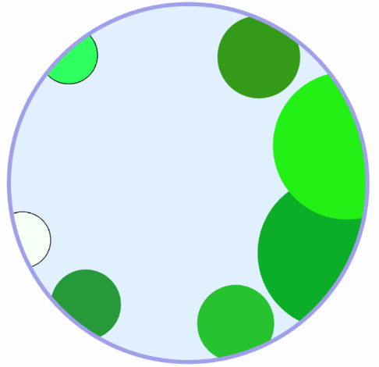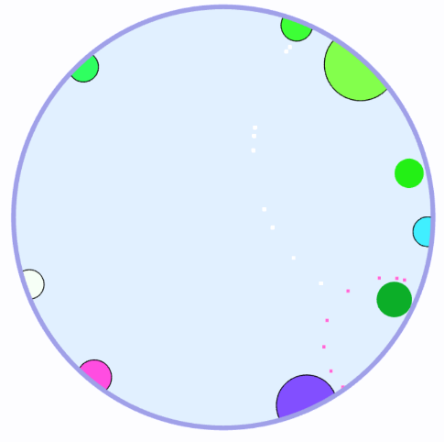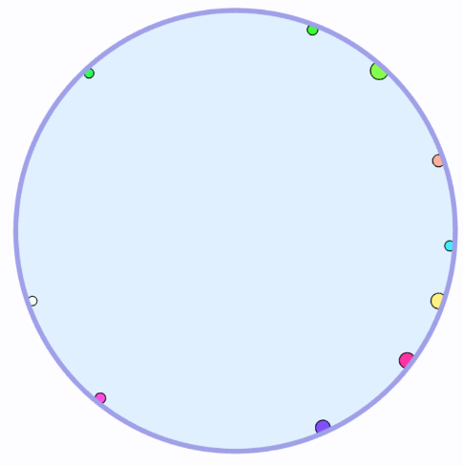9. The goal of the player is to remove every bacterium before any two reach the goal. This is pretty straight forward, and happens as shown below

A couple moves in. Poison has been dropped and killed a few bacteria.

Start of the game, no poison added yet.

With all the bacteria removed, the player has won the game!

The goal is then shown, and as we can see, the first moves were the decisive moves.

With that, the player can click play to play again.

The poison has grown significantly, and the player is close to winning.

Note: the light green bacteria in the top left actually reached the goal, but since a second one hasn’t made it close, the player hasn’t lost.

Bonus:

We finished the main game relatively quickly, and with the extra time we decided to tackle all of the bonus. Even if only two are counted, the bonus makes the game more fun, and so here’s features:

1. When we click the left mouse button, instead of simply eliminating the bacterium, we drop a drop of poison on the petri dish. That poison grows, similarly to the bacteria, and when it comes in contact with a bacterium, proceeds to kill it. The poison grows until the game is won or lost. This is shown below:

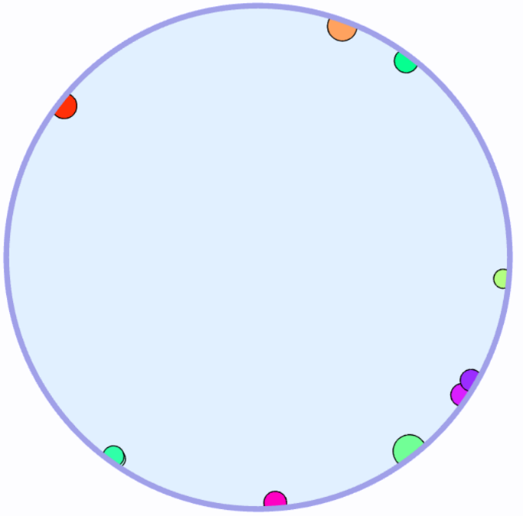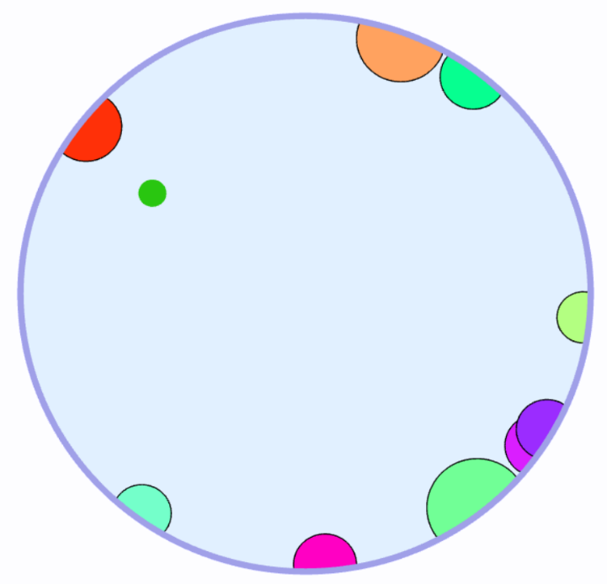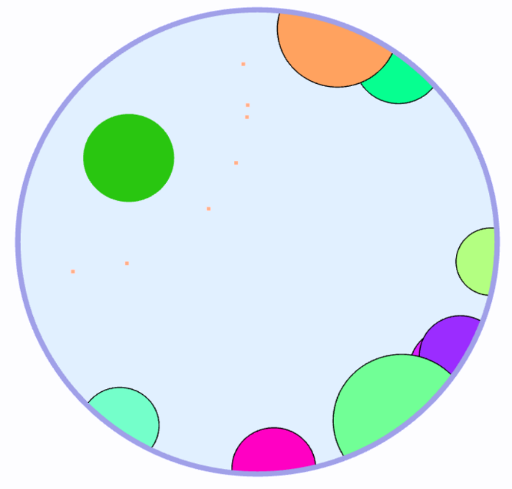

Poison grows until it touches and kill the red bacterium.

After the poison has been deployed.

Start of the game, before deploying poison

2. Due to the random placement of bacteria, and our particular win conditions, the merging of two bacteria would be counter productive to the game. We still wanted bacteria to merge together, though, so we made it that when one bacteria totally eclipses another, the two merge, and create a bacteria (of the same size as the larger of the tow) with a new color! This is shown below:

Brown consumes cyan, creating a new cell with the average of their colors!

Looks like pink’s next…

Before the merge. The brown is growing significantly faster than the cyan. Thus, when brown eclipses cyan…

3. Finally, is our group’s favorite – the particle effect. When a bacteria is poisoned, it doesn’t *immediately* cease to be drawn. Instead, when a bacteria comes in contact with poison, it enters a dying state. In this state, it quickly shrinks, to its original size. After that, the bacteria explodes in a fantastic fashion! Only once the explosion ends, is the bacteria no longer drawn. This is shown below:

This has been the Screenshot Gallery for Buggu Game. If you have any questions, feel free to contact us via canvas. Thank you for taking the time to read.